GCSE ENGLISH COURSE OUTLINES
ENGLISH LANGUAGE | ENGLISH LITERATURE
Paper 1 - 1hr 45minutes  Explorations in Creative Reading and Writing  Reading – one literature fiction (40 marks)  -1 short form question  -2 longer form questions  -1 extended question  Writing – descriptive or narrative (40 marks) | Paper 1 - 1hr 45minutes  Shakespeare and the 19th-century novel (64 marks)  Section A – Romeo and Juliet or Macbeth students need to write in detail about the extract and then the play as a whole. 4 marks awarded for spelling, punctuation and grammar.  Section B – Jekyll and Hyde or A Christmas Carol. Students answer in detail about the extract and then the play as a whole.
Paper 2 – 1hr 45minutes  Writers’ Viewpoints and Perspectives  Reading – two linked non-fiction texts (40 marks)  -1 short form question  -2 longer form questions  -1 extended question  Writing – extended writing task to present a viewpoint (40 marks) | Paper 2 - 2hr 15minutes  Modern texts, Power and Conflict poetry and unseen poetry (96 marks)  Section A – An Inspector Calls students answer one essay on either theme or character  Section B – Power and Conflict students compare one named poem from P&C anthology with another of their choice  Section C – students answer a question on one unseen poem and one question comparing this poem with a second unseen poem
Non-exam assessment:
Spoken Language
-presenting
-responding to questions and feedback
-Use of Standard English





How can you support your child at home?









Great revision texts and supporting guides:
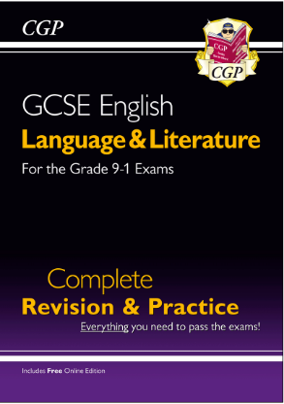
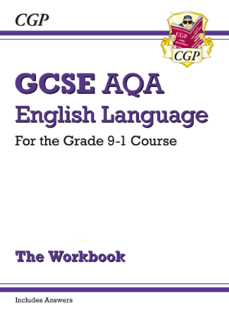
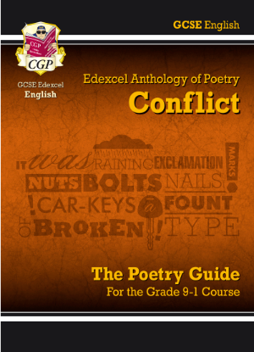
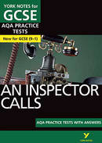
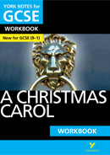
CGP or York Notes

Keys to Success!
How can you support your child at home?
We promote SMART revision strategies vital to success- quality, focused revisiting is key in line with latest metacognition research. We need your help to promote this at home too!
- Check that your child is logged in to the App and Seneca Learning
- Ask your child about their private study/ word of the day in form time
- Purchase some of the suggested revision materials overleaf- include workbooks so that students are doing the activities
- Encourage attendance at revision classes on Mondays
- Promote and partake in short snappy activities for content revision where students are physically working with materials- arranging, copying out, covering, transforming.
- Encourage the use of colour, image and language to maximise long term retention by using both sides of the brain – mind maps really do work!
- Test your child on their quotations often to check knowledge is embedded – continue to revisit this
- Promote the different support materials available- Mr Bruff and Akala videos if you feel your child needs to change it up! Variety is key!
- SUMMARISE, DEDUCE and EVALUATE activities at every opportunity - i.e “Summarise the plot of Jekyll and Hyde for me…” Create opportunities to talk about English
- Promote reading as far as possible- shorter snappier non-fiction articles as well as ambitious fiction
- Encourage timed examination pieces closer to the examination period- rehearsing hand written responses is vital to student success
- Encourage students to read creative writing aloud to you – this improves editing skills
- Encourage breaks in revision (typically a short break after a 45 min revision session)
- Praise your child when they do any of the above!

The National Changes to English…
- NO tiers of entry- all students take the same examinations regardless of ability across the 9-1 grade range
- More reading and harder vocabulary- all papers require students to read and understand extracts quickly and they contain increasingly difficult vocabulary
- Better quality writing- all papers, across both Literature and Language, also require students to write better quality responses to show their understanding. This means that students need to use better vocabulary and sentence types to allow themselves to convey complicated ideas.
What support are the students getting in school?
- Quality first teaching and support in the classroom
- Additional support from TAs and specialists for students who require support
- Bespoke revision classes on Mondays after school tailored to the ability of students. Students need to sign up so we can plan accordingly.
- Word of the day in form time- drip feeding new vocabulary each day!
- Directed revision tasks set for private study at home and in form time including…
- Revision set on Doddle
- Seneca learning log in
- PiXL Literature App log in
- Printed PiXL independence booklets- one for every unit of study!
- Past paper questions
- Thinking Hard style activities

