Level 3 Mathematical Studies

Hinchingbrooke School

Summer work

NAME: ________________________________

GCSE grade _____

Core Maths – Transition work Summer

Welcome to the Core maths course! The work below is to be completed over the summer to prepare you for the start of the course.

Please spend QUALITY time on this work, showing your METHOD to get the solutions. A large part of marking in Core maths is being able to justify an answer even if the solution you found is not perfect! Choose ONE of the following questions.

Question 1

What would be cheaper to do: ▪ Build a rocket to get to the moon Or:
▪ Create a stack of pound coins to reach the moon?
The question here is left intentionally vague to get you thinking. Research as much as you can (google) and (stating your assumptions) create a presentation to discuss your findings (this should be around 1 page of A4 minimum so you will need to spend some time really thinking about this). Your presentation should take around 5 minutes.

Question 2
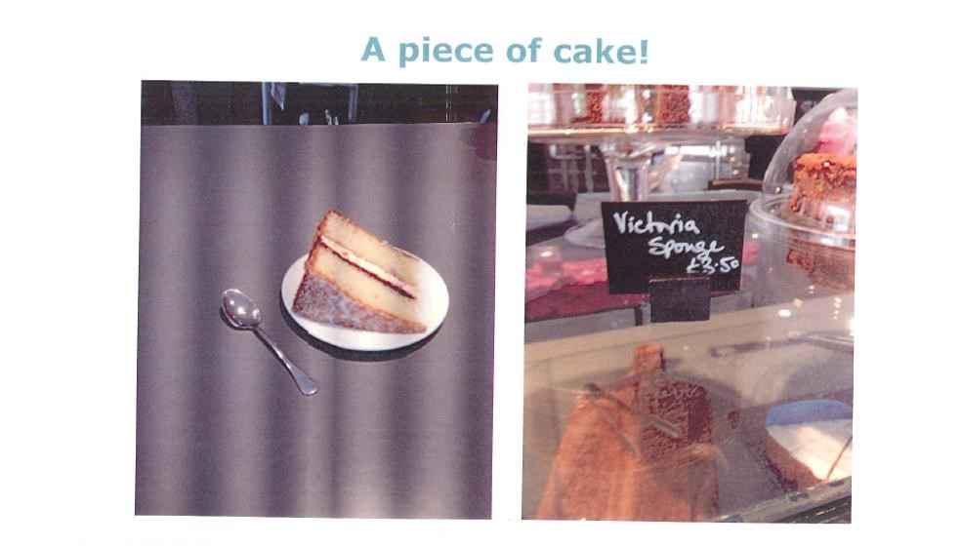

How much profit is the cake shop making on this cake? Feel free to use google to help you here. Again, make sure you are showing all your workings and assumptions. You will be expected to present this to the class at the start of the course (this should be 1 page of A4 minimum so you will really need to go into some detail). Your presentation should take around 5 minutes.

As part of the course there are some areas of mathematics that you will be expected to be already proficient.

These areas are:

- Percentages and percentage change using a multiplier
- Cumulative frequency and Box plots (creating and comparing)
- Histograms
- Pythagoras
- Scatter graphs and drawing a line of best fit

Below are some questions on these topics that you “should” already be able to answer. Feel free to use any resource available to you (revision guides, internet, etc) to help answer these questions to the best of your ability. Leaving a question blank because you do not know how to answer it is not acceptable as you have permission to look up how to answer questions!

Q1.
A train ticket costs £23.50
The price increases by 6%.
Felix has £100.
Can Felix buy four tickets at the new price?
_______________________________________________________________________
_______________________________________________________________________
_______________________________________________________________________
_______________________________________________________________________
_______________________________________________________________________
(Total 4 marks)

Q2.
In 2015, Han was paid £1350 per month.
In 2016, he
had a 2% increase in his monthly pay.
worked 37.5 hours per week.
worked for 47 weeks.
Work out Han’s average pay per hour for 2016
_______________________________________________________________________
_______________________________________________________________________
_______________________________________________________________________
_______________________________________________________________________
_______________________________________________________________________
_______________________________________________________________________
Answer £ _________________________________________
(Total 5 marks)
Q3.

The cash price for a boiler is £2000
Customers can pay the cash price or pay monthly.

Cash Price  £2000 |  | Pay Monthly  60 monthly payments of £40
Work out the percentage increase from the cash price when paying monthly.
_______________________________________________________________________
_______________________________________________________________________
_______________________________________________________________________
_______________________________________________________________________
_______________________________________________________________________
_______________________________________________________________________
_______________________________________________________________________
_______________________________________________________________________
Answer _______________________________________ %
(Total 4 marks)
Q4.
Julie works 20 hours each week.
She earns £7.50 per hour.
She saves one-fifth of her earnings.
She wants to buy an iPad costing £429.
How many weeks does it take her to save enough to buy this iPad?
You must show your working.
_______________________________________________________________________
_______________________________________________________________________
_______________________________________________________________________
_______________________________________________________________________
_______________________________________________________________________
_______________________________________________________________________
Answer _________________________________________
(Total 4 marks)
Q5.
Andrew is paid £250 a week.
Each week, he
shares his pay with his sister in the ratio 3 : 2
saves 12% of his share.
How many weeks will it take Andrew to save £360?
_______________________________________________________________________
_______________________________________________________________________
_______________________________________________________________________
_______________________________________________________________________
_______________________________________________________________________
_______________________________________________________________________
_______________________________________________________________________
_______________________________________________________________________
Answer _________________________________________
(Total 5 marks)

Q6.
Here is some information about the test marks of 120 students.

Mark, m | 0 < m ≤ 10 | 10 < m ≤ 20 | 20 < m ≤ 30 | 30 < m ≤ 40 | 40 < m ≤ 50
Frequency | 20 | 28 | 40 | 20 | 12

(a) Complete the cumulative frequency table.

Mark, m | m ≤ 10 | m ≤ 20 | m ≤ 30 | m ≤ 40 | m ≤ 50
Cumulative frequency | 20 | 48
(1)
(b) Draw a cumulative frequency graph.
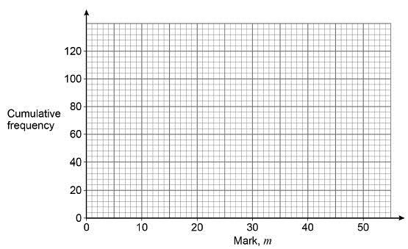
(2)
(c) Students who scored 15 marks or fewer take another test.
Use your graph to estimate how many students take another test.
___________________________________________________________________
___________________________________________________________________
Answer _________________________________________
(2)
(Total 5 marks)

Q7.
Type A batteries and type B batteries were tested.
The cumulative frequency diagram shows information about the battery life of type A.
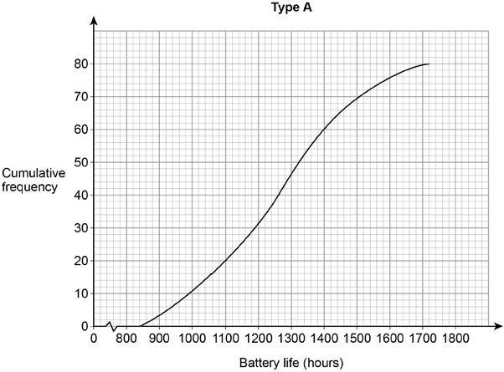
(a) Estimate the interquartile range for type A.
___________________________________________________________________
___________________________________________________________________
Answer _________________________________________ hours
(2)
(b) Estimate the number of type A batteries that had a battery life of more than 1600 hours.
___________________________________________________________________
___________________________________________________________________
Answer _________________________________________
(1)

(CONTINUED OVER THE PAGE)
(c) The box plot shows information about the battery life of type B.
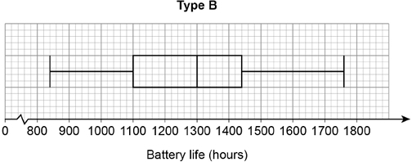
On average, which type had the greater battery life?
Tick a box.

 | type A |  |  | type B
Using data from both diagrams, state how you chose your answer.
___________________________________________________________________
___________________________________________________________________
___________________________________________________________________
___________________________________________________________________
___________________________________________________________________
___________________________________________________________________
(2)
(Total 5 marks)

Q8.
Here is some information about the times people took to complete a survey.

Fastest time | 3 minutes
Slowest time | 18 minutes
Median | 11 minutes
Lower quartile | 7 minutes
Interquartile range | 8 minutes
Ben draws this box plot to show the information.
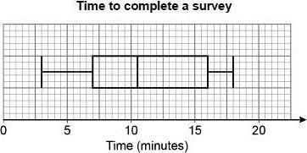
Make two criticisms of his box plot.
Criticism 1 ______________________________________________________________
_______________________________________________________________________
_______________________________________________________________________
Criticism 2 ______________________________________________________________
_______________________________________________________________________
_______________________________________________________________________
(Total 2 marks)

Q9.
In a survey, queuing times at supermarket checkouts were recorded.
One morning, samples of 50 customers were taken at supermarkets A, B, C and D.
The box plots represent the results.
Queuing times
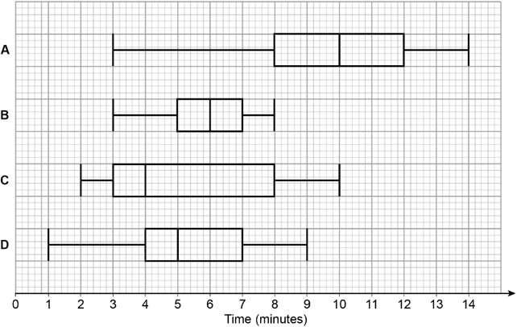
(a) On average, which supermarket had the lowest queuing times?
Give a reason for your answer.
Supermarket _______
Reason ____________________________________________________________
___________________________________________________________________
(2)
(b) At which supermarket were the queuing times most consistent?
Give a reason for your answer.
Supermarket _______
Reason ____________________________________________________________
___________________________________________________________________
(2)
(Total 4 marks)

Q10.
Here is some information about the ages of people at a concert.

Age, x (years) | Frequency
10 ≤ x < 15 | 8
15 ≤ x < 25 | 24
25 ≤ x < 40 | 30
40 ≤ x < 70 | 39
Draw a histogram to represent the information.
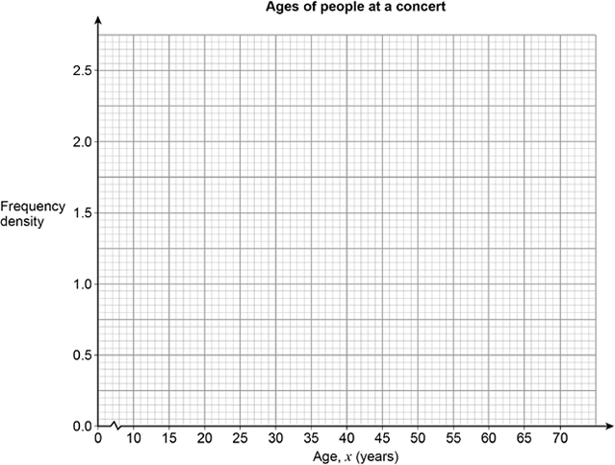
(Total 3 marks)

Q11.
Here is some information about a tennis club.
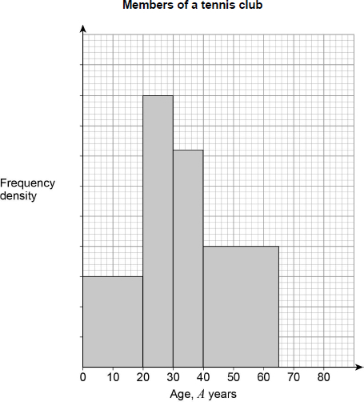
There are 30 members with A < 20
There are 12 members with 65 ≤ A < 20
There are no members with A ≥ 80
(a) Complete the histogram.
___________________________________________________________________
___________________________________________________________________
___________________________________________________________________
___________________________________________________________________
___________________________________________________________________
(3)

(CONTINUES OVER THE PAGE)
(b) Work out the total number of members of the club.
___________________________________________________________________
___________________________________________________________________
___________________________________________________________________
___________________________________________________________________
___________________________________________________________________
Answer _________________________________________
(2)
(Total 5 marks)
Q12.
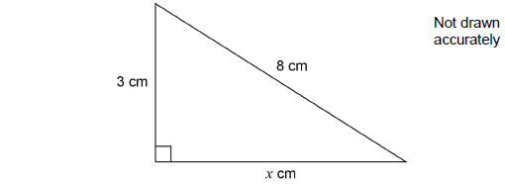
Work out the value of x as a decimal.
_______________________________________________________________________
_______________________________________________________________________
_______________________________________________________________________
_______________________________________________________________________
_______________________________________________________________________
_______________________________________________________________________
_______________________________________________________________________
_______________________________________________________________________
Answer _________________________________________
(Total 3 marks)

Q13.
Here is a right-angled triangle.
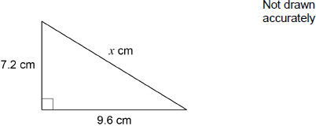
Show that x = 12
_______________________________________________________________________
_______________________________________________________________________
_______________________________________________________________________
_______________________________________________________________________
_______________________________________________________________________
_______________________________________________________________________
_______________________________________________________________________
_______________________________________________________________________
_______________________________________________________________________
(Total 2 marks)

Q14.
A shop sells raincoats and umbrellas.
The scatter graph shows the monthly sales for 12 months.
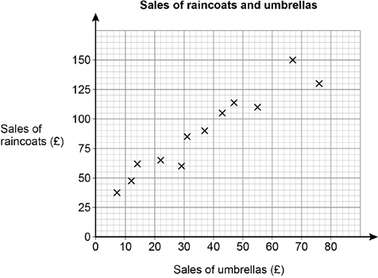
(a) Write down the type of correlation shown by the graph.
Answer _________________________________________ °
(1)
(b) The manager expects the sales of umbrellas next month to be £60
Draw a line of best fit to estimate the sales of raincoats next month.
Answer £ _________________________________________
(3)
(Total 4 marks)

