Summer preparation for Year 12 Politics
On the following pages, you will find a selection of articles and suggested activities to prepare you for Year 12 Politics.

Hinchingbrooke School
Edexcel Politics (9PL0)
Specification: www.tinyurl.com/EdexcelPolitics

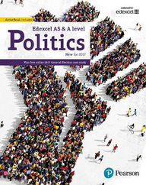
The topics that you will learn are:
- UK Politics and Core Political Ideas
- UK Government and Non-core Political Ideas
- Comparative Politics

The textbook that we use in school is:
- Edexcel GCE Politics AS and A-Level. (ISBN: 978-1292187020)

Textbooks are not mandatory but may support you in your private study periods and at home. The department has the e-book available for students to use.

If you choose to buy your own, please look around on several websites to save you money!

Our department twitter account regularly shares current research and articles that are relevant to all areas of Social Science, including Politics.
@HBKSocSci
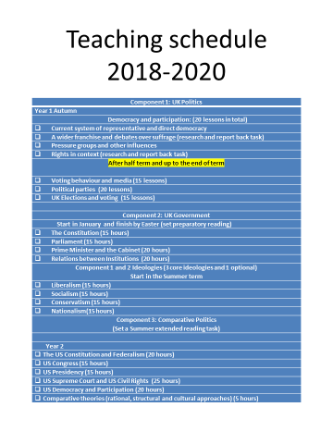
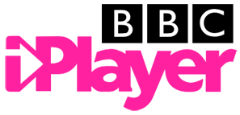
Politics is everywhere, so you’ll be able to see aspects of it in all forms of media. Try searching for the following titles and make notes on any videos you watch, try to keep it relevant to the topics taught in Politics (see above).
- Question Time / Sunday Politics / Panorama (BBC iPlayer)
- I, Daniel Blake / Yes Prime Minister / Yes Minister (Netflix)
- Margaret Thatcher: The Woman Who Changed Britain (Youtube)
- Dispatches (4OD)
Make any notes from your video observations here:

Different political articles with questions to provoke critical thinking.
Immigration
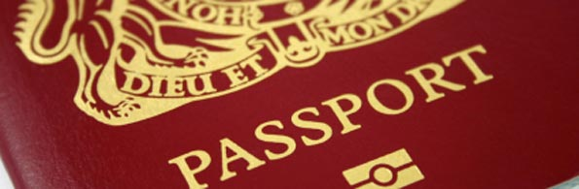
Why is immigration a good thing?
Cultural Exchange: Immigration leads to exchange of cultural values. It results in an exchange of knowledge and expertise between two nations. It serves as an opportunity to interact with people of other countries. It gives a platform for people from diverse backgrounds to come together and share their views.
New Avenues in Education and Career: Immigration brings in new opportunities for people of different countries. It exposes people of a nation to the atmosphere of another country that may be very different from one's motherland. It results in exchange and sharing of knowledge between nations. This opens doors to many new fields of education and career opportunities.
Economic Growth: Immigration results in an open global market. It gives a global perspective to the social and economic growth of society, thus widening the scope for development. With new opportunities in career and education, comes economic growth. Supporters of immigration believe that it has the potential of bringing about global prosperity.
Distribution of Population: In some cases, immigration may result in a fairer distribution of population. Migration of people from an overpopulated country to a scarcely populated one balances population density. Some countries face a dearth of resources due to their rising population, while others are blessed with ample resources but have a very thin population. Migration from a thickly populated nation to a thinly populated one can prove to be a blessing for both countries.
Why is immigration a bad thing?
Population Imbalance: Crowding, that is, increase in the population density in certain regions, is one of the basic disadvantages of immigration. Migration of people from one country to another leads to crowding in one nation as opposed to deserting of another. It implies an excessive use of the resources of one nation that may lead to imbalance of natural resources.
Transfer of Diseases: Immigrants may bring with them, diseases that prevailed in their country. Disease-causing agents may transfer from one country to another through immigrants, thus leading to spread of diseases. To reduce the risk of transfer of diseases, many countries have started carrying out screening of immigrants on their arrival in the country. Reportedly, AIDS was transferred to the United States in 1969 through one infected immigrant from Haiti.
Unfair Distribution of National Wealth: Those opposing immigration argue that the jobs available in the country and the nation's wealth are its property and that allowing immigration implies the distribution of this property among the non-natives. Immigration implies the distribution of a nation's wealth to those who do not have a right on it.
Financial Burden: The costs incurred in the provision of resources such as education and health facilities to the immigrants are a burden on the nation that hosts immigrants in large numbers. Some say that the economic growth brought about by immigration is nullified by the costs that the nation's government has to bear in providing the immigrants with the resources.
Malpractices: Less educated immigrants are believed to increase theft, violence and other malpractices in a nation. People from diverse backgrounds that migrate across national boundaries may put national security at stake. Illegal immigration that has emerged in some parts of the world has proven to be a curse to the nations' economies and their social welfare.
Brain Drain: Some oppose immigration on the grounds of brain drain that results from it. What, according to some, is sharing of knowledge between nations, is for others, knowledge drain. When a nation loses its people to another country, it also loses its talents. A poor country might end up donating its educated minority to other richer countries, due to immigration.
What is coalition policy on immigration?
Although the coalition agreement makes no mention of an overall target range for net immigration, the government does, in practice, have a target of reducing net migration to the tens of thousands by the end of this Parliament. At a joint press conference with Nick Clegg on 20 May 2010 launching the coalition policy document, the Prime Minister said:
"In terms of immigration, what you can see is that there's a cap going to be put in place and, yes, that is with the ambition of getting to levels of net migration that were prevalent in the 80s and 90s, which is tens of thousands not hundreds of thousands."
The Queen's Speech included the following passage:
"The government has agreed that there should be an annual limit on the number of non-EU economic migrants admitted into the UK to live and work." This is one of the ways we will reduce net migration back to the levels of the 1990s - tens of thousands, not hundreds of thousands."
Theresa May, the Home Secretary has repeatedly reiterated the government's promise to get net migration down to the tens of thousands by the end of the Parliament including during a speech delivered to the Conservative Party Conference in 2012 in which she set out the reasons why a robust immigration policy should be in place. [8] Some of her arguments reflected those which had previously been made by Migration Watch UK.
The coalition government has implemented an annual cap on some non-EU economic migration as a means of reducing net migration; this cap, set at 20,700 per year, limits the number of people who can be sponsored by their employer to come to work in the UK came into force on 6 April 2011. Only about half the quota has been issued.
The government has also introduced new measures to tackle widespread abuse of the student visa system, including ensuring that all colleges are 'highly trusted' and restricting the right to work of some students. The government is also beginning to roll out an extensive system of student interviews to prevent abuse.
In 2012 the government introduced more stringent requirements for those wishing to bring in family members. Elderly parents can only enter the UK if no one is able to look after them in their own country. Sponsors of spouses now have to prove a minimum income of £18,600 to ensure that the spouse does not become a burden on the tax payer.
The almost automatic link between work permits and settlement that existed under Labour has now been broken. Only those earning over £35,000 will be able to apply for indefinite leave to remain.

Further Reading
Home Office Immigration Statistics (Jan-Mar 2013)
https://www.gov.uk/government/uploads/system/uploads/attachment_data/file/201099/immigration-q1-2013snr.pdf

Migration Statistics Quarterly Report
http://www.ons.gov.uk/ons/rel/migration1/migration-statistics-quarterly-report/may-2013/index.html
Overall, do you think immigration is a good or bad thing for the UK?
Scandal
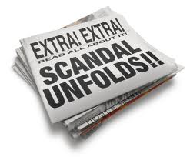
What is a scandal?
A political scandal is an action or event regarded as morally or legally wrong and causing the general public outrage. Scandals take many forms, often including bribery, expenses, affairs, drugs and other serious faux pas.
Examples of high profile political scandals
Chris Huhne  (2013) | Former Energy Secretary Chris Huhne and his ex-wife Vicky Pryce were both jailed for eight months almost exactly a decade after he asked her to take his speeding points on her licence. The Judge said Huhne had lied 'again and again' to avoid prosecution
Liam Fox  (2011) | Fox resigned as Defence Secretary in October 2011, after it was shown that he had broken the ministerial code in allowing Adam Werritty improper access to government. Werritty - who had been Fox's best man - had printed business cards claiming to be an adviser to the defence secretary, despite not being appointed as a special adviser. Fox quit after an internal investigation showed clear breaches of the ministerial code.
David Laws  (2010) | Lib Dem David Laws resigned as Chief Secretary to the Treasury just days after the coalition was formed. He had been claiming expenses on his boyfriend's flat. The Laws scandal was complicated by the fact that he'd done this not for obvious financial gain, but to avoid disclosing that he was gay.
MP's Expenses Scandal: Sir Peter Viggers  (2009) | The floating duck house became synonymous with the MPs expenses scandal after Sir Peter Viggers tried to claim for an ornamental duck house. The receipt, from a company specialising in 'bird pavilions' said: "Price includes three anchor blocks, duck house and island."
Lord Mandelson  (2008) | Resigning twice from cabinet positions following scandals, the first in 1998 concerning an interest free loan, and the second in 2001 alleging that he influenced a passport application. He has now been made a life peer in the House of Lords.
Cash for Honours  (2007) | One of the low-points in Tony Blair's time in Number 10 - the suggestion was that Labour party lenders were being offered peerages and other honours. The allegations led to a police inquiry which ran for nearly 18 months. Nobody was charged in connection with the probe, but the allegations were highly damaging to Blair's premiership.
Mark Oaten  (2006) | Oaten was forced to resign from his bid for Liberal Democrat party leadership and step down from parliamentary office in 2006 after it was revealed that he had slept with a 23-year-old male prostitute between 2004 and 2005
Jo Moore  (2002) | Jo Moore, spin doctor for then-transport secretary Stephen Byers wrote an email suggesting that the bombing of the Twin Towers in New York City produced a ripe opportunity for slipping in some unflattering transport statistics. After the email was leaked she was forced to resign in 2002.
John Major & Edwina Curry  (2002) | John Major and Edwina Currie's four-year affair began in 1984, but was only revealed in her 2002 memoirs.
Jeffrey Archer  (2001) | Archer's political career ended in disgrace after he was convicted and imprisoned for 2 years for perjury and perverting the course of justice in 2001.
Ron Davies  (2001) | Ron Davies, former Secretary of State for Wales, was mugged at knifepoint after going out for a meal with a man he met on Clapham Common, a notorious gay rendezvous. He infamously called it a "moment of madness" at the urging of Tony Blair's Press Secretary Alastair Campbell. He later said he had been bisexual for some time, and was suffering from a personality disorder which caused him to take unnecessary risks. He stood down from Parliament at the 2001 general election.
Cash for Questions  (1994) | Al Fayed accused MPs of taking bribes to ask questions in parliament. Neil Hamilton subsequently took Al Fayed to court and lost. Two Conservative MPs Graham Riddick and David Treddinick were also implicated in the scandal that followed.
David Mellor  (1992) | Subject of a kiss and tell scandal in 1992. It was alleged that actress Antonia De Sancha and Mellor had an extra marital affair involving toe sucking and dressing up in a Chelsea FC football strip. However it was a holiday paid for by the ruler of Abu Dhabi that led him to resign from his post as Secretary of State for National Heritage later on in 1992.

Further Reading
The Telegraph’s Investigation: MPs Expenses
http://www.telegraph.co.uk/news/newstopics/mps-expenses/
MPs Expenses
http://www.guardian.co.uk/politics/mps-expenses
Gone but not forgotten? The Expenses Scandal Four Years On
http://www.psa.ac.uk/political-insight/blog/gone-not-forgotten-mps%E2%80%99-expenses-scandal-four-years
MPs Expenses: Timeline
http://www.independent.co.uk/news/uk/politics/mps-expenses-scandal-the-timeline-1888349.html
David Laws Resigns
http://www.telegraph.co.uk/news/newstopics/mps-expenses/7783687/David-Laws-resigns-over-expenses-claim.html
Mark Oaten
http://www.independent.co.uk/news/uk/politics/mark-oaten-on-the-scandal-that-ruined-him-1787299.html
Cash for Honours
http://news.bbc.co.uk/1/hi/uk_politics/4812822.stm
Cash for Questions
http://www.independent.co.uk/news/uk/politics/cashforquestions-mps-suspended-by-commons-1616440.html
Members of the government resign for a range of reasons. Using the link below, read about some of the more high profile resignations, and summarise the circumstances of at least three below. https://www.independent.co.uk/voices/lord-bates-top-10-ministerial-resignations-a8190556.html

Europe
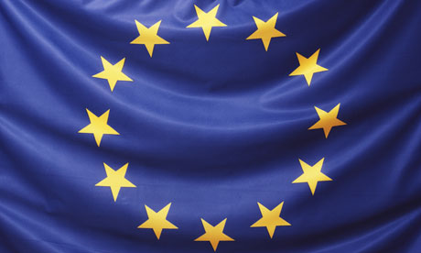
What is the European Union?
The EU is an international organisation that was set up and developed in the post-second world war period. Founded at a time when most European States were counting the costs of two wars which had ravaged the European continent, its ideals were simple: to establish a stable economic and political partnership between democratic European countries. Its main purposes are:
- Fostering democracy and political union in place of war.
- Economic union and the removal of trade barriers.
- Intergovernmental co-operation in foreign and security policy.
- Co-operation in justice and home affairs.
What is the European Constitution?
The Treaty for the Establishment of a Constitution in Europe (commonly referred to as the EU Constitution) was written by a Convention that met from 2002. On 29 October 2004, the heads of the EU's then 25 member states signed the Constitutional Treaty and started the ratification process.
The EU Constitution would have shifted the European power balance and changed its decision-making process. It was emphasised that the Constitution was intended to represent a treaty between co-operating states, not the formation of a 'super-state' - but this remained the primary concern of critics of the text. In June 2005, the French and Dutch electorates both rejected the Constitution in referenda, causing the project to stall.
Following the rejection of the 2004 draft Constitution, EU leaders supportive of a European Constitution (notably the German Chancellor Angela Merkel and French President Nicolas Sarkozy) explored other means of introducing constitutional provisions. Developments culminated at the EU summit of June 2007 under the German Presidency of the European Council; constitutional issues were brought back onto the agenda and all 27 EU states agreed on a mandate for an Intergovernmental Conference (IGC) to draft a new 'Reform Treaty'. A new Treaty was drafted and subsequently signed in Lisbon in December 2007 (therefore it is known as the Lisbon Treaty). With its aims to draw together resources and to harmonise policies, critics were concerned that the new Lisbon Treaty was simply a reformulation of the original, rejected, EU constitution.
However, the 'constitutional project' faced further problems. To come into force, the Treaty needed to be ratified by all EU member states, so when Ireland rejected the Lisbon Treaty in a referendum in June 2008 there was intense debate and speculation about the future of the Lisbon Treaty. The EU decided to take measures to encourage Ireland to ratify the Treaty: a number of 'protocols' were negotiated and added to the Treaty. Ireland then successfully ratified the Treaty following a second referendum in October 2009.
Before Germany ratified the Lisbon Treaty, the German Parliament passed new legislation to strengthen its role in implementing EU legislation to ensure that the EU could not 'exceed the powers given to it'. The EU-sceptic President of the Czech Republic, Vaclav Klaus used delaying tactics as he vehemently opposed the Treaty. Nevertheless, the Czech Republic became the last member state to ratify the Treaty when President Klaus finally signed it on 3 November 2009. The Lisbon Treaty came into force in December 2009.
What is EU Law?
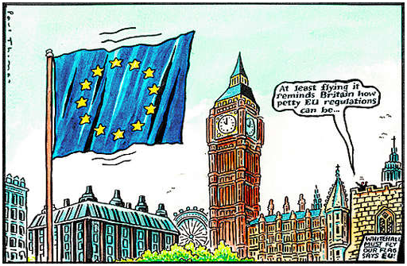
Under UK law, Acts of Parliament are not challengeable unless they conflict with European law. Apart from Treaties, there are two main ways in which European law is made:-
Regulations
A regulation takes precedence over any member state’s domestic law that is inconsistent with it. Member states are not required to make additional domestic laws to implement regulations. Individuals can rely on regulations in any court cases in their own country. An example of a regulation is Regulation 1408/71 which deals with EU nationals’ entitlement to social security benefits when in other member states.
Directives
Directives set a goal which must be reached by a certain date. Member states are responsible for making their own laws in order to reach this goal. An example of a directive is the EC Package Travel Directive, which was incorporated into UK domestic law by the Package Travel, Package Holidays and Package Tours Regulations 1992.
What are the benefits of EU membership?
There are a lot of people who see the EU as a great thing. These supporters identify a number of reasons for the UK playing an active part in the development of the EU, for example:
- it can share power between countries of varying size and wealth
- it can resolve conflict and offer European countries a stronger voice on the international stage
- through the EU countries can work out issues that don't 'respect borders' like the environment, immigration, terrorism and employment
- it allows EU citizens to work, study and move freely between member countries
- EU countries can have trade agreements with each other and as a result more stable economies
- signing the UK up to the Euro, say supporters, would make it easier to buy and sell on the world market
What are the drawbacks of British membership of the EU?
- Cost. The EU costs the UK £6.4bn. The Bruges (which is an anti-European group) claim the cost per head of EU membership is £873, but according to Foreign and Commonwealth office the cost is about £300 per head.
- Inefficient Policies. A large percentage of EU spending goes on the Common Agricultural Policy. For many years this distorted agricultural markets by placing minimum prices on food. This lead to higher prices for consumers and encouraging over-supply. Reforms to CAP have reduced, but not eliminated this wastage.
- Problems of Euro. Membership of the EU doesn't necessarily mean membership of the Euro. But, the EU has placed great emphasis on the Single Currency. However, it has proved to have many problems.
- Net Migration. Free Movement of Labour has caused problems of overcrowding in UK cities. The UK's population is set to rise to 70 million over next decade, partly due to immigration. This has pushed up house prices and led to congestion on roads.
- More bureaucracy less democracy.
What is the ‘bailout’?
A bailout is a colloquial pejorative term for giving a loan to a company or country which faces serious financial difficulty or bankruptcy. The term is maritime in origin being the act of removing water from a sinking vessel using a smaller bucket.
The European Union has helped to ‘bailout’ several member countries in the most recession including; Ireland, Greece, Spain, and Portugal. Other countries are struggling to avoid the need for a ‘bailout’ in the economic climate, for example, Cyprus and Slovenia.
Some believe simply bailing out member countries from debts they have accrued encourages risky lending and borrowing beyond their means, others believe it is essential to ensure the stability of the European economic markets.
Further Reading
Profile: The European Union (BBC News)
http://news.bbc.co.uk/1/hi/world/europe/country_profiles/3498746.stm
The EU: What’s in it for me?
http://www.the-eu-and-me.org.uk/
Chart: How much does Britain pay into the EU and what does it get back?
http://www.thisismoney.co.uk/money/news/article-2052433/Chart-How-does-Britain-pay-EU-does-back.html
What are the benefits of staying in the European Union?
http://www.telegraph.co.uk/news/worldnews/europe/8965907/What-are-the-benefits-of-staying-in-the-European-Union.html
UK and EU: Better off out or in?
http://www.bbc.co.uk/news/uk-politics-20448450
European Debt Crisis
http://topics.nytimes.com/top/reference/timestopics/subjects/e/european_sovereign_debt_crisis/index.html
Viewpoint: Why bailouts are bad
http://www.bbc.co.uk/news/magazine-15155395
Are you in favour of the UK leaving the EU or not?

