Religion, Philosophy and Ethics Eduqas A Level
Transition Work

The Eduqas Religious Studies specification is split into three components:
- Study of Religion – Christianity
- Philosophy of Religion
- Religion and Ethics
Each of these make up a third of your A Level course. Please find relevant transition work for each component detailed in this booklet. These will aid your understanding of the topics that we will study in September and therefore, it is essential you complete all tasks and bring these with you to your first lesson. They will give your teachers an idea of your engagement and enthusiasm towards the course.
Please note: there is no expectation for you to buy all of the books suggested for wider reading throughout. They are merely recommendations if you are curious about what is to come!

Christianity Transition Work
Something to watch:
You need to have a good background knowledge of Christianity and the Bible for the course. Therefore, watch all of the videos on the following Youtube Biblical Themes playlist https://www.youtube.com/watch?v=XzWpa0gcPyo&list=PLH0Szn1yYNec-HZjVHooeb4BSDSeHhEoh Using these and your own additional research, answer the questions below:
- The Story of the Fall?
What happens?
How does this story link with Christian ideas about Jesus?
- The story of Exile
Where, when and why were the Israelites exiled to?
What does the prophet Jeremiah teach about exile in Babylon?
What is the link with Jesus?
- The Suffering Servant passages of Isaiah
Who was Isaiah?
What is the background to Isaiah’s writings?
What does Isaiah write about the suffering servant?
What is the link with Jesus?
- The Prophets (there is a Bible project video called prophets)
What do prophets do? Who are they?
What do they teach about the covenant?
What is the Day of the Lord? What is the link with Jesus?
- The Messiah
What does the Old Testament teach about the Messiah?
Why do Christians believe that Jesus was the Messiah?
What Jewish expectations of the Messiah does Jesus not fulfil?
- Jesus
What are the main events in Jesus’ life?
What does Jesus teach in the Sermon on the Mount?
What does Jesus mean when he calls himself the Son of Man?
What is the day of the Lord?
10 Incredible Facts about the Birth of Jesus Christ that will surprise you: https://www.youtube.com/watch?v=54DX5D5IMYE. Make notes on each of these.

Something to read:
Article on the following link: https://www.catholic.com/magazine/online-edition/do-the-infancy-narratives-of-matthew-and-luke-contradict-each-other. Please take note of the source of this article and the impact that this will have on its audience and overall bias.
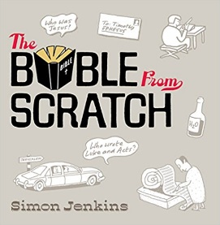
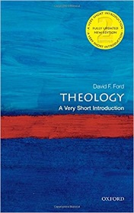
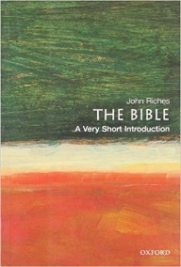
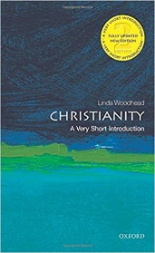
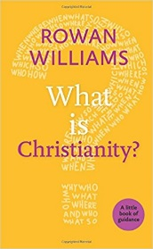
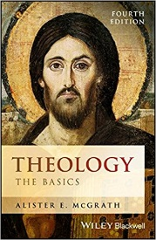
Suggested wider reading:

Theology: The Basics, by Alister E. McGrath
What is Christianity? by Rowan Williams
Christianity: A Very Short Introduction by Linda Woodhead
The Bible: A Very Short Introduction by John Riches
Theology: A Very Short Introduction by David Ford
The Bible from Scratch by Simon Jenkins

Analysis and Evaluation:
Use what you have watched and read to complete the following tasks:
- Summarise the birth of Jesus in Matthew’s gospel in your own words.
- Summarise the birth of Jesus in Luke’s gospel in your own words.
- ‘The two birth narratives contradict each other’. Explain your view on this statement in as much detail as possible.

Philosophy of Religion Transition Work
Something to watch:
Aquinas and the Cosmological Crash Course Philosophy #10: https://www.youtube.com/watch?v=TgisehuGOyY. Make notes on how Thomas Aquinas tried to prove the existence of God.
Watch this debate between William Lane Craig and Christopher Hitchens: https://www.youtube.com/watch?v=e8MzPmkNsgU The video is called DEBATE: Atheist vs Christian (Christopher Hitchens vs William Lane Craig). If you watch from 12 minutes you will see William Lane Craig and Christopher Hitchens being introduced. William Lane Craig is a Christian and Christopher Hitchens was a New Atheist. The lecture is quite long and so you may wish to watch this in stages. They talk for 20 minutes each and then have a right of reply each.
- William Lane Craig starts at 13 minutes
- Christopher Hitchens starts at 33minutes and 30 seconds
- Williams Lane Craig replies to Christopher Hitchens from 54 minutes and 15 seconds
- Christopher Hitchens replies to William Lane Craig from 1hr and 7 minutes
From one hour 20 minutes there is a cross examination that you may wish to watch.
Having watched the videos you are going to complete a Cornell Notes activity. There are instructions on how to take Cornell Notes on this video: https://www.youtube.com/watch?v=ErSjc1PEGKE The video is called: How to take Cornell Notes properly.

Something to read:
Read the attached article on the Cosmological Argument. If you print it off, you can highlight the key ideas, terminology and arguments.

Analysis and Evaluation:
Use what you have watched and read to complete the following tasks:
- Write down three arguments Aquinas gave for the existence of God. Explain these in your own words, as clearly as possible.
- Give an example to illustrate each of these arguments.
- Write a paragraph explaining your own view on whether Aquinas has successfully proved the existence of God.

Ethics and Religion Transition Work
Something to watch:
Utilitarianism – Crash Course Philosophy: https://www.youtube.com/watch?v=-a739VjqdSI&t=511s. Make notes on Bentham and Mill’s utilitarianism.

Something to read:
Read the attached article on Utilitarianism from RS Review magazine. If you print it off, you can highlight the key ideas, terminology and arguments.
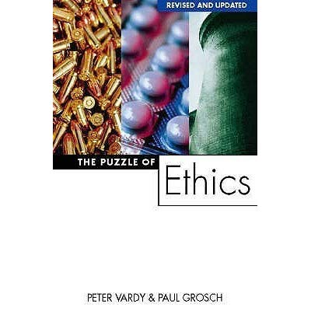
Read the chapters below from The Puzzle of God by Peter Vardy and Paul Grosch. This book is easy to purchase online and you should be able to pick up a second hand copy for very little. If you cannot get hold of a copy, let Miss Newman know and I will see about sending you some pages electronically.
You will need to fill in a Cornell notes page on each of the following topics:
Chapter 3 Aristotle and Virtue Theory
Chapter 4 Aquinas, Natural Law and Proportionalism
Chapter 6 Bentham and Mill – Utilitarianism
Chapter 10 Situation Ethics
At the end of each chapter there are some questions that can guide you in your note taking.
Suggested wider reading:
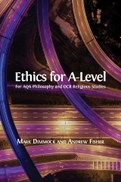
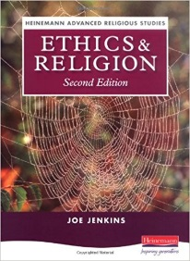
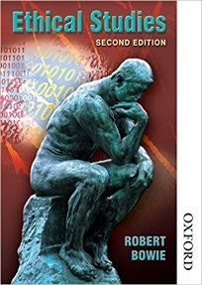

Access to Religious Studies: Ethical Studies by Robert Bowie
Ethics and Religion by Joe Jenkins
Ethics for A Level by Mark Dimmock and Andrew Fisher – free to download in PDF format on the following link: https://www.openbookpublishers.com/product/639/ethics-for-a-level

Analysis and Evaluation:
Use what you have watched and read to complete the following tasks:
- Summarise Bentham’s act utilitarianism and Hedonic Calculus in your own words.
- Summarise Mill’s rule utilitarianism and harm principle in your own words.
- ‘Act utilitarianism is a more practical way to make moral decisions than rule utilitarianism’. Explain your view on this statement in as much detail as possible.

