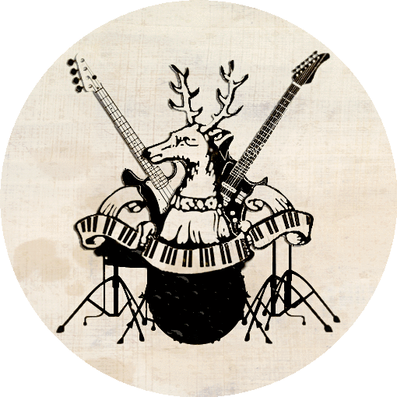

Dear Parents / Carers,
Glastonbrooke Unplugged
31.03.22
We are proud to announce that Glastonbrooke unplugged is running again this year. We are very pleased that your son / daughter has expressed an interest in taking part in Glastonbrooke Unplugged. The event is taking place at Hinchingbrooke House in the Old Dining Room. The event will start a 19:00 and should finish no later than 21:00. Tickets will be £5 and available on the door or https://www.ticketsource.co.uk/pac/glastonbrooke-unplugged/e-lpljaj

Please could you sign and return the permission slip below as soon as possible.

Kind regards,

The Glastonbrooke Team
…………………………………………………………………………………………………………………………………………………………

To Mrs Nichols | Mr Howells

I give permission for my son/daughter to perform at Glastonbrooke Unplugged on 31.03.22

Student name _________________________________________________ Form ________________
My child has the following medical condition of which the school should be aware
__________________________________________________________________________________
A contact number ___________________________________________________________________
Name of parent/carer __________________________________
Signature of parent/carer _______________________________ Date _____________

Thank You
The Glastonbrooke Team
glastonbrooke@hbk.acesmat.uk

