
Hinchingbrooke School [Insert date]
Brampton Road
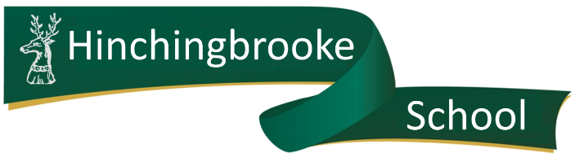
Huntingdon
CAMBS
PE29 3BN

Re: Subject Access Request (SAR)

Please provide me with the information about me that I am entitled to under the UK General Data Protection Regulation. This is so I can be aware of the information you are processing about me, and verify the lawfulness of the processing.
Here is the necessary information:
Name and Form Group:
Relationship with the school | Please select:  Pupil / parent / employee / governor / volunteer  Other (please specify):
Correspondence address
Contact number
Email address
Details of the information requested | Please provide me with:

Signed: _____________________________________________________

If you need any more information, please let us know as soon as possible.
Please bear in mind that, in most cases, we must supply you with the information within 1 month and free of charge.
If you need any advice on dealing with this request, you can contact the Information Commissioner’s Office on 0303 123 1113 or at www.ico.org.uk

Hinchingbrooke School [Insert date]
Brampton Road
Huntingdon
CAMBS
PE29 3BN

Re: subject access request
Please find the information that you requested under the UK General Data Protection Regulation (UK GDPR).

Your name

Your relationship with the school | Pupil / parent / employee / governor / volunteer /  other (specify)
Details of the information you requested/enclosed
Date you requested the information
Date we supplied the information
Format we supplied the information

If you need any further advice relating to your subject access request, you can contact:
appeals@hinchbk.cambs.sch.uk

Yours sincerely,
Hinchingbrooke School

