Hinchingbrooke TAG Grading Process
BEFORE THE GRADING PROCESS BEGINS
Students who have chosen not to attend assessments should have a ‘0’ recorded for said assessment. They should NOT have the opportunity to re-sit. This should be noted on their QA Record Sheet.
Substitutions or discounted evidence – Please ensure this is clearly marked on the student’s QA record sheet in the comment box, to show what work has been replaced or cut, before the grading process.
Mitigating Circumstances – if you have been asked to substitute work or discount evidence, this should be done before the grading process.

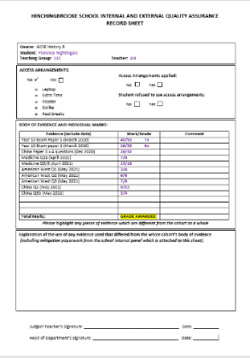
If the majority of statements are highlighted, repeat the process for the statements in the next descriptor up
FOR MID-PHASE STUDENTS, AP STUDENTS AND THOSE WITH RECENT ILLNESS
A student who has very little work, and/or has chosen not to attend TAG assessment lessons/has been caught cheating and so has scored ‘0’ for some assessments.

If there are at least 2 substantial pieces of work and this fits into a descriptor then please award that grade (see worked examples student 5).

If the work does not fit into the descriptor for a grade 1/E then the work should be awarded a U grade
Class teacher and HoD need to sign the sheet to sign off that grade as part of the QA process
Record the grade decided upon on the QA Record sheet for that student
Record the grade decided upon on the QA Record sheet for that student
If none or only a few statements from the descriptor can be highlighted, then decide whether the student should be awarded the in between grade (if there is one) by looking at the boards exemplification work and the worked examples booklet or if you need to go back to the original grade.
Class teacher and HoD need to sign the sheet to sign off that grade as part of the QA process
Remember:
The most recent work carries the greatest weight, so if a student has work representing a range of grades, but the most recent fits the Grade 4 description, then this is the grade that should be awarded.
Highlight all the statements in the descriptor you can evidence in the body of work
If there is a grade available, select the lowest one and read through the JCQ descriptor for that grade. If you have no grade available you will need to start by reading and highlighting the descriptor for grade 2.
Fill in the QA Record Sheet for the student with marks and grades (where a full exam paper and published mark scheme has been used)
QA Record sheets for each department will have the JCQ Grade Descriptors on the back for ease of use. Faculty Administrators can be used to fill in the sheets with the grades/marks prior to a grading meeting using the department spreadsheet. All portfolios of work should be kept out of the way, preferably under lock and key.
FOR THE MAJORITY OF THE COHORT

